FCS Desktop/Server Support Guidelines

Fujitsu Computer Systems Corporation will be providing support for Fujitsu Siemens Volume Products that have been purchased within the U.S by our SOC’s or Global Accounts.

The following table displays the current Desktop and Volume products. Please be familiar with these models and note that many of the products have model names similar to those of our laptops.

IF YOU HAVE ANY QUESTIONS, OR ARE UNCLEAR ABOUT THE MODELS OR PROCESSES, ESCALATE THE CALL TO LEVEL 2 SUPPORT.

Note: All products highlighted in gray are in the process of being phased out or have already been phased out and are no longer available for sale.

Current Desktop/Volume Products
Esprimo Professional PC’s |  | Celsius Workstations
Esprimo C |  | Celsius K320
Esprimo E |  | Celsius K330
Esprimo P |  | Celsius M420
 |  | Celsius M430
 |  | Celsius R610
 |  | Celsius R630
 |  | Celsius V810
Current Scenic Desktop PC's |  | Futro Thin Clients
Scenic Desktops are being phased out with the introduction of the Esprimo Desktop Line |  | Futro A100
Scenic C610 |  | Futro C200
Scenic C620 |  | Futro S210 (32MB)
Scenic E600 |  | Futro S220 (128MB
Scenic E620 |  | Futro S230 (256MB)
Scenic N320
Scenic P300
Scenic P320
Scenic W600
Scenic W620
Handhelds |  | FSC Mobile Products
Pocket Loox 600 |  | Celsius Mobile H210
Pocket Loox 610 |  | Celsius Mobile H230
Pocket Loox 420
Pocket Loox 710
Pocket Loox 718
Pocket Loox 720

Earlier Desktop Models
Scenic Professional PC |  | Celsius Workstations
Scenic D |  | Celsius 444
Scenic L |  | Celsius 670
Scenic S2 |  | Celsius M410
Scenic T
Scenic xB |  | Futro Thin Clients
Scenic C300 |  | Futro B210
Scenic C600 |  | Futro B220
Scenic E300 |  | Futro D100
Scenic N300 |  | Futro C100

Customers who have purchased these products will call in for support though the Premium Care Support number (1-866-756-8628). Callers will be required to enter an ID number to continue on to a Support Representative. The customers Pin numbers will begin with either 75 or with 76. Customers who call in for server support will be directed to GSC. Those calling for desktop support will be directed to Memphis for support (7:00 AM - 7:00 PM CST Monday through Friday) or Stream (5:30 PM CST -8:00 AM CST Monday through Friday, all day Saturday, Sunday, and Holidays).

Customers who enter their ID incorrectly or exceed the number of allowed attempts will be forwarded to Level 1 Support for further assistance.

Customer PINs are displayed on the customer information screen in Clientele. If a customer does not know their ID number, locate their record in Clientele the same way you currently would. The ID number will be displayed at the top of the customer record.

IF A CUSTOMER IS CALLING IN FOR ETERNUS OR PRIMERGY/PRIMEPOWER SUPPORT THEY WILL BE DIRECTED TO THE GSC SUPPORT LINE ESTABLISHED FOR THEM WHEN THEY ENTER THEIR PIN NUMBER.
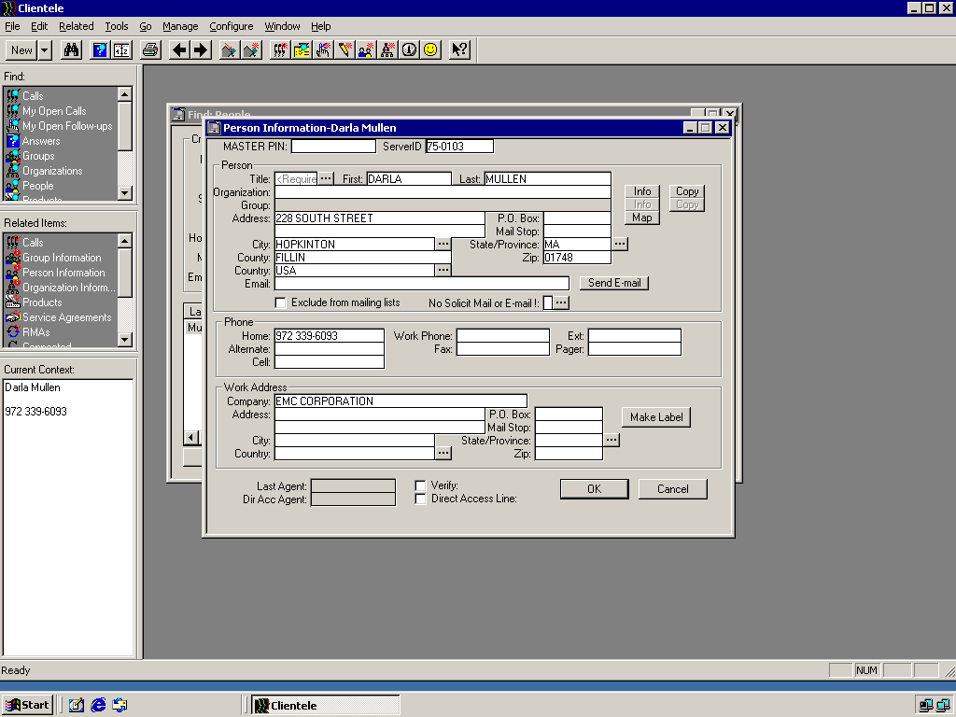

Once you have given the customer their ID number, warm transfer the customer to the Fujitsu Premium Care line (513-336-1545). Please note: this is for Servers and Storage Devices only. If the customer has a desktop issue, go ahead and provide support for the customer.

IF YOU HAVE ANY QUESTIONS, OR ARE UNCLEAR ABOUT THE MODELS OR PROCESSES, ESCALATE THE CALL TO LEVEL 2 SUPPORT.

